 | DIDCOT & WALLINGFORD NEIGHBOURHOOD POLICING TEAM  QUARTERLY UPDATE  SEPT-NOV 2025
 | Welcome to the Neighbourhood Team’s first newsletter for schools.  We are keen to share information with you all about current trends and challenges that are affecting our communities, and invite feedback from parents about the issues that matter the most to you and your children, as well as offering advice on how to manage issues at present.
 | 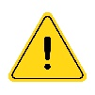  Did you know that it is illegal to ride a privately owned electric scooter (e-scooter) in public?  That’s because e-scooters are classified as motor vehicles by law. So, in theory, this means that you need an MOT, road tax and insurance to use one. However, it is not currently possible to register e-scoters in this way.  The statistics for e-scooter accidents in the UK reveal a pattern of increasing casualties, particularly during the summer months. In 2023, there were 1,387 recorded casualties among e-scooter riders and pedestrians, including six fatalities.  Privately owned e-scooters can only be used on private land, with the permission of the landowner.  You cannot use a privately owned e-scooter on a road, pavement or in a public space. If you do, then you risk having your e-scooter seized and destroyed, face a large fine and even points on your driving licence! Should you not currently hold a license, these points can be added in the future once you obtain your license.  Some parts of the UK are running government trials of rental e-scooters. If you are over 16 and have a full or provisional driving licence, then you can rent these and use them on public roads and cycle paths (Just check that your driving licence covers categories AM, A or B).
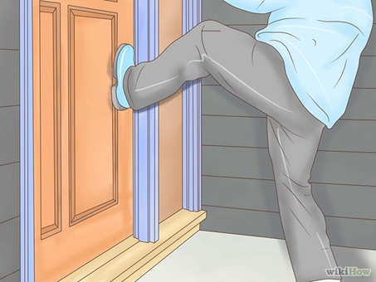  🚨 TREND WARNING 🚨 DOOR-KICKING CHALLENGE | We are urging our community to stay alert to a dangerous social media trend known as the door-kicking challenge. This viral TikTok trend involves individuals—often teenagers—kicking or banging on doors late at night or in the early hours, filming the act for social media.  This behaviour has been reported across the UK and even internationally, including in the USA.  ⚠️ Important Reminder:  Even if no theft or burglary occurs, this is still illegal. It’s classed as anti-social behaviour and vandalism, and can lead to criminal charges. More seriously, it can be mistaken for an attempted break-in, potentially triggering defensive or dangerous responses from residents.  👨‍👩‍👧‍👦 Parents & Guardians:  Please speak with your children about the risks and consequences of participating in trends like this. What may seem like a prank can cause real harm, fear, and long-term impact—especially for vulnerable individuals and families.  Do you know what your kids get up to when outside the home?  👮‍ The Neighbourhood Policing Team is working closely with local schools and communities to identify those involved. Anyone caught will receive a more formal visit from Thames Valley Police.  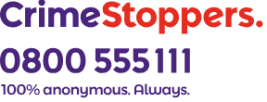  If you have any information about these incidents, you can report them via 101, online at Home | Thames Valley Police or anonymously via  You can also discuss any concerns with the school pastoral care teams, or safeguarding leads.
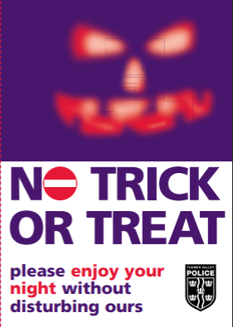   | During this quarter we approach two events in which we want everyone to have a good time. It’s a time we want everyone to enjoy in their own ways, and for some that will involve not wanting to be disturbed.  To make sure we can all enjoy the upcoming celebrations of Halloween, we ask the following to ensure all can enjoy their day.  If you have young children:  • Never let them go trick or treating on their own.  • Make sure you accompany them and only visit people you know.  If you have teenagers:  • Make sure they don’t have access to fireworks, alcohol, eggs or flour.  • Explain why they must not play tricks on strangers.  • Tell them that if nobody answers  the door, or a ‘No trick or treat’  sign is on display, they must leave immediately.  • Remind them to stay with their  friends and make sure they know  that they should never enter the  home of a stranger  Shortly after Halloween we have celebrations of November 5th. Bonfire night is one we would all like to “remember, remember”, but for the right reasons, and not the wrong ones.  It is vital that no one under the age of 18 has access to fireworks, so please ensure your children stay away from these for the safety of everyone. On the evening of bonfire night, the time in which fireworks can be set off is no later than midnight. Please respect these times to ensure everyone in the local community can enjoy this occasion in their own ways.  For advice on fire safety, please refer to advice from Oxfordshire Fire and Rescue.  Most importantly, keep yourselves and everyone else safe, look out for each other, and have a good time!
   | Your feedback is really important to us, and helps form our policing priorities.  Have Your Say! Meetings are a great forum to feedback your concerns, and also anything positive! You can find a list of upcoming meetings on our TVP Website  If you haven’t done so already, you may like to sign up to Thames Valley Alert, so that you can receive free crime alerts and information about where you live. To do this you can either go to www.thamesvalleyalert.co.uk or use the following barcode:  

