Sensory Mark Making
Children love to explore with their hands and they love to draw and write in a variety of different ways. Try filling a tray (a baking tray will work well) or a large plastic container, with some of these common items. Talk to your child about how it feels, draw together, see if they can write their name or challenge them to draw something specific. Trace a pattern and see if they can copy it.
You can use fingers, pencils, paintbrushes or be creative and use cars, knives, forks, toy animals – anything that will leave a mark!
When you have finished, pour it back into a zip lock bag or an air tight container and it will be there next time you want to use it.

Rice you can colour rice by putting a cup of rice in a sealable bag,
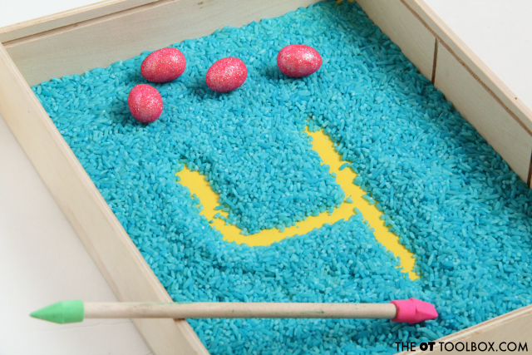
You can colour rice by putting a cup of rice in a sealable bag, along with a few drops of food colouring, or some paint, then pouring onto a tray and baking on a low temperature in the oven until it is dry. Or you can mix some glitter it into it for some easy ‘magic’.
https://www.forkandbeans.com/2019/02/19/rainbow-rice/

Lentils Glitter
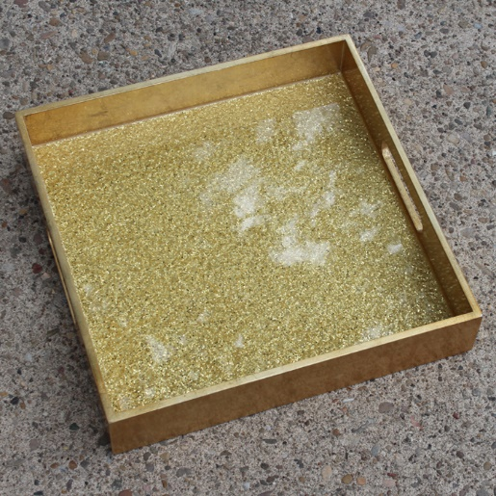
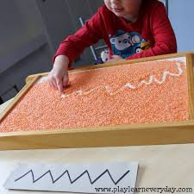

You can also use dried beans, cous cous, oats, crucnched up Weetabix – basically anything.

Flour
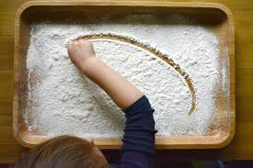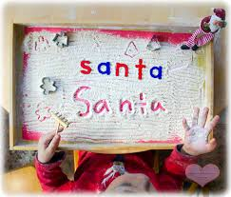

Really simple. Pour some flour. Add some letters or numbers to copy or just let them use their imagination.

Gloop
(This can get messy…an old t-shirt and a wipeable surface is recommended. But it will wash out)
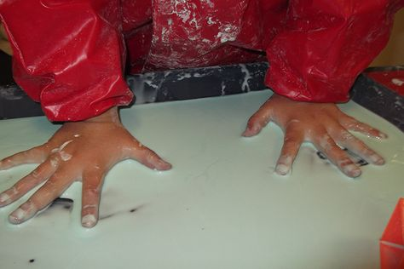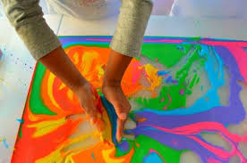
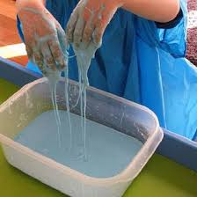
If you add some water to cornflour you get a woonderful mixture called gloop. Its wet and liquid, dripping off your fingers, but when you squeeze it, it goes hard. You can also squeeze some paint into the tray and let your child mix the paint in with the gloop. Put 2 differnet colours in. What colour will the gloop be? Add some green and it looks like slime. On a sunny day take this outside and add spoons, animals, dinosaurs and let their imaginatiosn run wild.

Trace one of these patterns…can your child copy it underneath?

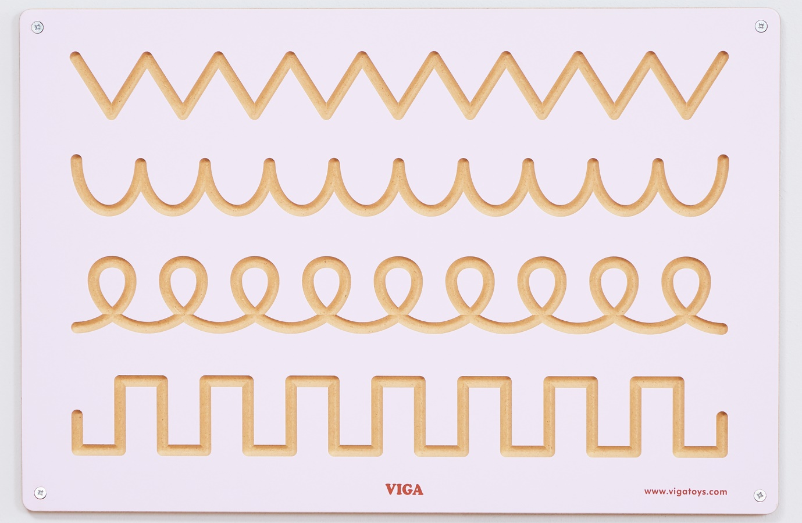

Pre Writing Shapes – here are some shapes that your child could try to make or copy, either in a sensory tray or using pens/ pencils/ crayons.


