Sound | Grapheme | Picture | Word
/s/ | s | 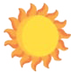 | sun
/a/ | a | 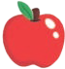 | apple
/t/ | t | 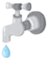 | tap
/i/ | i | 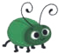 | insect
/p/ | p |  | pan
/n/ | n |  | net
/m/ | m | 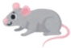 | mouse
/d/ | d | 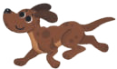 | dog
/g/ | g | 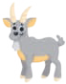 | goat
/o/ | o |  | octopus
/k/ | c | 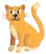 | cat
/k/ | k | 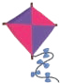 | kite
Mnemonic system
A mnemonic system is a way of helping children to remember letter- sound correspondences. The words for the key pictures are not decodable at the point of introduction − the pictures are serving as a visual and oral mnemonic to help children recall the focus letter-sound.

Sound | Grapheme | Picture | Word
/k/ | ck | 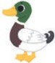 | duck
/e/ | e | 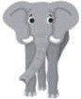 | elephant
/u/ | u |  | umbrella
/r/ | r | 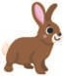 | rabbit
/h/ | h |  | hat
/b/ | b | 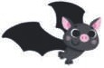 | bat
/f/ | f | 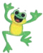 | frog
/f/ | ff | 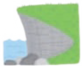 | cliff
/l/ | l |  | ladder
/l/ | ll |  | shell
/s/ | ss | 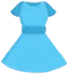 | dress
/j/ | j |  | jug
/v/ | v | 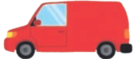 | van
/w/ | w | 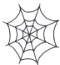 | web
/k+s/ | x | 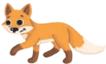 | fox

Sound | Grapheme | Picture | Word
/or/ | or |  | fork
/ur/ | ur |  | purse
/ou/ | ow | 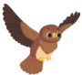 | owl
/oi/ | oi |  | coin
/eer/ | ear | 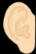 | ear
/air/ | air | 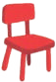 | chair
/y+oor/ | ure |  | manure
/uh/ | er | 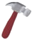 | hammer
/w/ | wh | 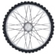 | wheel
/f/ | ph |  | dolphin
/ai/ | ay | 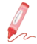 | crayon
/ai/ | a–e |  | cake
/ai/ | a | 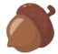 | acorn
/ee/ | e–e | 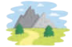 | scene
/ee/ | ie |  | shield
/ee/ | ea | 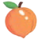 | peach

