  a  All around the apple down draw in the hook |   b  Down the bat and hook right over the ball |   c  Curl around the caterpillar | 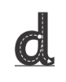  d  Around the bottom up the tall neck and down to the feet |   e  Chop off the top and scoop out the egg
  f  Hook over the flower down and hook the roots. Draw in the leaves | 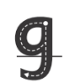  g  Around the goat’s face and down hook under his chin |   h  Down the horse’s neck to its feet and back over its body | 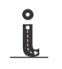  i  Top to toes and dot her head |   j  Down into the jar and hook the jam. Dot the lid
  k  Down the kangaroo to his feet, come up and hook right to make a pouch, down to his feet. | 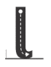  l  Down the long leg |   m  Down, up and over the mountain. Back up and over the mountain again. | 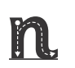  n  Down the post and back up to hook over the net |   o  All around the orange
  p  Down the princess plait, back up and hook right over and round her face | 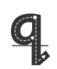  q  Hook left over the queen’s face round to her crown, down and give her a swish |   r  Down the robot and back up to hook over his arms |   s  Slither down the snake |   t  Down the tree and across the branch.
  u  Down, hook under the umbrella, up to the top and down again and flick |   v  Down the vase up the vase |   w  Down the wave, up the wave, down the wave and up the wave. |   x  Down across the track and across the track the other way |   y  Down hook under the yacht and down draw in the anchor

z
zig to the right, zag, zig

