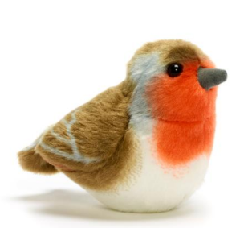 | 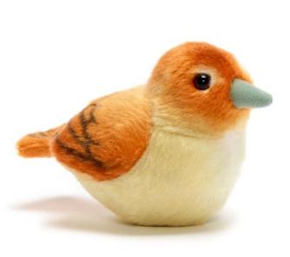 | 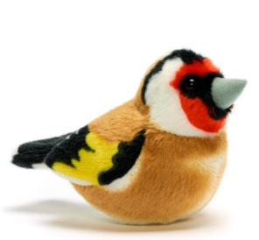 | 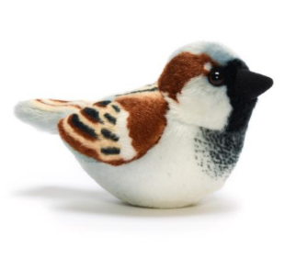 | 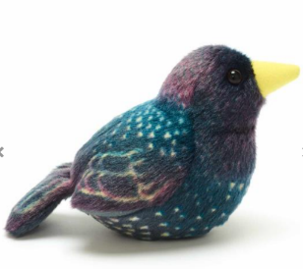
Robin  Monday | Nightingale  Tuesday | Goldfinch  Wednesday | Sparrow  Thursday | Starling  Friday
River-Reign  Luca  Lottie  Wilf  Mason | Nikol  Jonathan  Theo  Reggie  Solly | Florence  Thomas  Alfred  Sophie  Thea  Maria | Bodey  Millie  Leni  Autumn  Eli  James | Reading interventions


