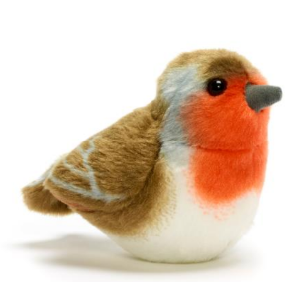 | 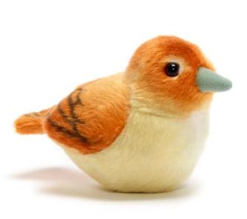 | 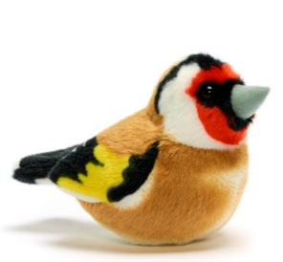 | 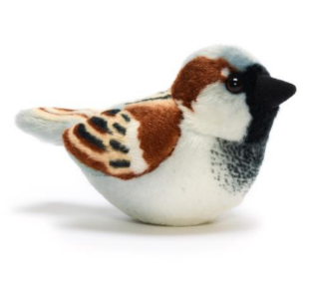 | 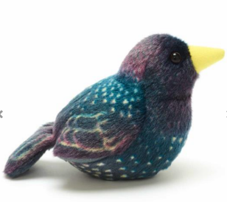
Robin  Monday | Nightingale  Tuesday | Goldfinch  Wednesday | Sparrow  Thursday | Starling  Friday
Wren  Max  Ava  Otis | Tommy  Ashton  Eli  Grayson  Avaiah | Holly  Faith  Roman  Niamh  Jasper | Isla  Evie-Mae  Rowen  Lily | Tilly  Lori  Michael  Maia


